# Meeting Outline - 2 April 2024

1. Simplified MSP structure
2. Outline of key data themes for MSP
3. Review of key national and regional datasets available for MSP for Kenya and Tanzania
4. Way Forward
   1. Formal project management and contracts etc need to be sorted out, formal inception etc asap but move forward as we can.
   2. Working documents folder - Kate share Box access, with editing permissions
   3. Skills matrix share - Edward to upload as well as other docs.
   4. Fill in data sets list - initial rapid filling by individuals by Friday?, national small team to engage next week and each week, biweekly region and international.

# Simplified workflow for a Marine Spatial Planning Process

| **Stage** | **Tasks** | **Technical Process** | **Stakeholder Process** |
| --- | --- | --- | --- |
| Identify relevant sectors using or potentially using the sea space (prioritize if needed) | · Review available data and documents to identify relevant sectors  · Shortlist and validate sectors to be involved | · Data and report review | · May be some general communications of MSP process  · Work towards engaging key sectors for later steps |
| Collate (and if needed develop) spatial data on sea uses by key sectors | · Gather existing spatial data  · Review gaps  · Develop collated layer for each sector | · Develop integrated layers for each key sector (i.e. the base map/s for each sector) | · Specific engagements with sectors to fill data gaps |
| Identify priority areas for each sector | · Assess status of key features (as needed)  · Priority use areas for each sector (define core areas of use or interest) | · Status assessment (if required)  · Develop single sector priority use maps (with relative use value and practical thresholds of interest) | · Specific engagement with sectors to develop and refine maps |
| Conflict areas | · Overlay priority use areas  · Examine conflicts and determine seriousness (no spatial overlap, no practical conflict, conflicts that are resolved through normal sea operational procedures, conflicts that need to be addressed through MSP zones)  · Workshop conflict areas that may need to be resolved through MSP | · Sea use conflict identification and prioritization  · Refine primary use areas as needed | · Expert workshops with small technical groups collectively and if need with specific sectors |
| Initial development of Sector plans - Sea use requirements for each sector | · Modified proposals for primary use areas for each sector that need to be secured through MSP  · Specification of compatible and incompatible activities for each sector | · Develop refined maps of primary use areas  · Develop tables of required sea use specifications in these areas | · Iterative technical engagement with sector representatives to refine primary use area proposals and required use specifications  · Initial evaluation of sector plans by each sector |
| The Sector plans - Draft proposed zones and sea use guidelines | · Develop draft primary use zones for each key sector  · Develop sea use guidelines for primary use zones  · Spatial resolution of conflict areas through technical proposals, bilateral and multisector meetings | · Formalize and finalize proposals for each sector  · Refine as needed  · Conflict resolution processes to refine areas or sea use specifications | · Notice of content is likely to need to be gazetted  · Draft zones and sea use guidelines need to be shared  · Fairly intense sector specific, bilateral and multisector processes to resolve conflicts as needed  · Share draft sector plans (as feasible) |
| Final zones and sea use guidelines | · Finalize primary use zones for each key sector  · Finalize sea use guidelines for primary use zones | · Package finalized use zones and sea use guidelines (i.e. the Marine Spatial Plan) | · Share final zones and guidelines for review and validation (usually via gazette or similar process)  · Government sign-off |

# 

# Data Initial Review

For datasets:

* Focus of full national coverage or where full extent of a feature is mapped (detailed but isolated local mapping is less useful)
* Is it easily available: (In hand, easy to get, permissions needed)

| **Item** | **Regional or global data that is available** | **Tanzania data that is available** | **Kenya data that is available** |
| --- | --- | --- | --- |
| **Biodiversity Sector: Biodiversity / Conservation / ecology / climate change adaptation** | | | |
| Data to support overall ecosystem mapping   * bathymetry * benthic type/ sediment | Bathymetry (for integrated map) |  |  |
| Integrated ecosystem maps (or similar)   * Marine habitats * Seabed habitat map integrated |  |  |  |
| Systematic or similar comprehensive spatial biodiversity prioritisations: (e.g. Areas suitable for expansion of marine conservation areas to meet the GBF 30x30 biodiversity target; optimal conservation sites) |  | Coastal (60m?) Marxan priorities - Heshimu Bahari |  |
| Systematic or other assessments of status of biodiversity features (ecosystems and species) |  |  |  |
| Systematic spatial data on human impacts on ecosystems that would not be covered by other sector data   * Sediment impacts * Pollution including plastics * Climate change impacts |  |  |  |
| Critical and/or sensitive habitats areas   * Inshore (coral, seagrass, mangroves etc.) * Offshore (Important or sensitive deep-sea features: seamounts, cold seeps, hydrothermal vents, etc.) | Inshore:   * Coral * Seagrass * Mangrove * Other coastal wetlands * Estuaries and deltas   Offshore:   * Ocean geomorphology datasets - bluehabitats.org data is useful basis |  |  |
| Priority areas for key species   * Key Biodiversity Areas * Designated priority areas through various international processes (IBAs, IMMAs, ISRAs) * Species priorities (e.g. Sea Turtle nesting & feeding; marine mammals: whales, dugongs; important marine bird areas | Sea Turtle nesting & feeding  Tracking?  IBAs, IMMAs, ISRAs | Turtles, dolphins, whales |  |
| Marine Protected Areas | WDPA |  |  |
| Locally Managed Marine Areas and Community Conserved Areas |  |  |  |
| Other place-based biodiversity conservation interventions   * Biodiversity monitoring sites * Restoration sites |  |  |  |
| Ecosystem services   * Assessments of priority areas for delivering ecosystem services | From Daniel Dunn:   * Mangrove-supported fishing effort * Carbon sequestration by mangroves * Number of people protected by mangroves * Value of properties safeguarded by mangroves * Fish and invertebrate abundance value of mangroves * Egg and larval export from MPAs |  |  |
| **Shipping Sector** | | | |
| Shipping routes and density | MarineTraffic / Global Fishing Watch / World Bank data |  |  |
| Ports and harbours | GFW anchorages |  |  |
| Dredging and dredge disposal |  |  |  |
| Ballast water exchange areas |  |  |  |
| **Coastal and Marine Tourism** | | | |
| Tourism use zones/areas  Tourist facilities |  |  |  |
| **Marine Waste Disposal** | | | |
| Marine Waste Disposal - Sewerage outfalls |  |  |  |
| **International communications** | | | |
| Subsea cables  Landing sites |  |  |  |
| **Fisheries** | | | |
| Fisheries (industrial/ offshore)   * Key fishing grounds for each fishery * Hotspots for various fisheries * Areas of highest catch and/or CPUE | Global Fishing Watch (some ability to split sectors) | -Fishing ground from eCAS  - hotspot areas for EEZ tuna fishery |  |
| Fisheries (artisanal/traditional)   * Community fisheries management areas * Use areas * Launch sites? |  |  |  |
| Spatial data on fish stocks / priority areas |  |  |  |
| **Aquaculture / Mariculture** | | | |
| Existing sites, zones or priority sites |  |  |  |
| **Mining and Related Activities** | | | |
| Coastal mining, coastal salt production etc |  |  |  |
| **Offshore petroleum exploration and production** | | | |
| Production sites / wells?  Exploration leases  Priority areas | WWF dataset - drilling info? | Oil and gas blocks and wells - national dataset, in hand |  |
| **Other spatial data that may be useful** | | | |
| Existing spatial management areas - Any designated use zones or similar |  |  |  |
| Others??? |  |  |  |

# Sections from various documents - relevant for data

## Regional via Daniel Dunn

Dear Stephen,

Look at this email from Daniel Dunn about the data issues that you were asking. Don’t you think if these datasets are available we can go ahead with Ke and Tz MSP support?

Hi Jeff & Zach!

All those strategy meetings sound painful!

I don’t know Joseph Maina, but the others might. We’ve been digging into what to do in data poor regions, and recently demoed our app for use in Kosrae (Micronesia). We had some on the ground survey data to work with there, but were also using high resolution regional and global data. See the full list et could use we could use below. It’s more than a reasonable start. We’ve also included links to the Weddell Sea and Kosrae apps.

Let us know if you have questions or would like to set up a time to chat!

Cheers,

D

**Species distributions & important areas**

* Distribution of 40,000 marine species (5 km)
* Important Areas
  + IBAs, IMMAs, ISRAs… all have identified locations in both countries.
* Sea turtle tracking data… we have some tracks from the region that could be worked up, unclear how many
* SWOT Sea turtle nesting beach locations (70 across the two countries)

**Habitats**

* Tidal marshes (10 m)
* Seagrass cover (5 m)
* Mangrove cover (10 m)
* Distribution of 60 mangrove species (1 km)
* Mangrove canopy height (12 m)

**Ecosystem services**

* Mangrove-supported fishing effort (1 km)
* Carbon sequestration by mangroves (1 km)
* Number of people protected by mangroves (per 20 km of coastline)
* Value of properties safeguarded by mangroves (per 20 km of coastline)
* Fish and invertebrate abundance value of mangroves (1 km)
* Egg and larval export from MPAs (10 km)

**Marine connectivity**

* Currents (hourly, 2 km)

**Climate**

* Earth System Model projections on warming, marine heatwaves, ocean acidification, oxygen, primary productivity (25 models, 4 scenarios, 50 km)
* HighResMIP - Regional climate model projections on warming, heatwaves, rainfall, cyclones (multiple models, 10 km)

**Human use**

* Built environment (30 m)
* Global Fishing Watch (100 m)

## Kenya:

13. Develop a comprehensive data capture/procurement programme including, but not limited to:

* Identify and map all traditional fishing grounds
* Identify and map all coastal tourism use zones
* Undertake a hydrographic data audit and gap analysis, using the IHO standard national assessment format, to assess the current status of nautical charting and hydrography in Kenya
* Identify, compile, merge and verify all existing data sets relating to the distribution of key marine habitats and species distribution/abundance
* Identify, compile, merge and verify all existing data sets relating to the distribution and abundance of key commercial fish stocks — both inshore and offshore
* Develop a detailed seabed habitat map of the entire coast and EEZ
* Develop detailed impact maps for the LAPSSET project to identify key impact zones from the development and zones of influence around the development that may affect other marine users in the vicinity
* Develop a representative spatial data set of international shipping movements throughout the EEZ (AIS data)
* Identify critical data gaps (e.g. seagrass distribution, offshore pelagic fishery resources

5.2.3 Future activities and uses being addressed

While fisheries and maritime transport have been highlighted as the key blue economy priorities, the full scope of

activities that either are, or are planned to be undertaken, must be addressed in the MSP as listed below:

* Inshore artisanal fisheries
* Offshore fisheries
* Shipping
* Coastal and marine tourism
* Marine biodiversity conservation and habitat protection
* Coastal livelihoods (associated with coastal habitats such as mangroves)
* Climate change adaptation
* Ports and port development
* Offshore petroleum exploration and production
* Dumping of waste at sea
* Maritime security and defence
* Subsea cables — international telecommunications

## Tanzania

1.4. SECTORAL SCOPE

The blue economy is not new to the URT, with marine uses and activities already contributing significantly to the overall socio-economic development of the URT, through direct economic activities, indirect support to service industries and the provision of environmental services. Since the economic benefits from ocean activities offer the potential for future growth, through both the expansion of existing sectors and the development of new activities, it is crucial that the full scope of activities that either are, or are planned to be undertaken under the umbrella of the blue economy, are addressed in the MSP.

The future development of the URT's marine space and the MSP framework encompasses various activities that are considered in-scope. These activities include marine biodiversity conservation and climate change adaptation, marine capture fisheries and aquaculture, ports and shipping, offshore petroleum exploration and production, coastal and marine tourism, subsea cables for electric transmission and telecommunications, and coastal salt production. These activities have been identified as significant components that require attention and planning within the URT's marine space and the MSP framework.

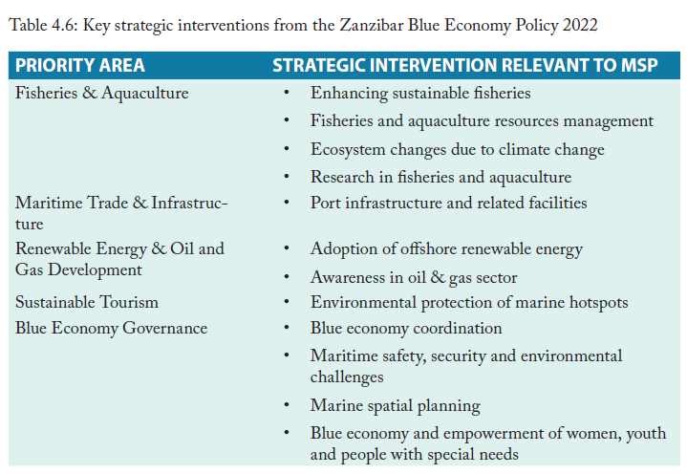

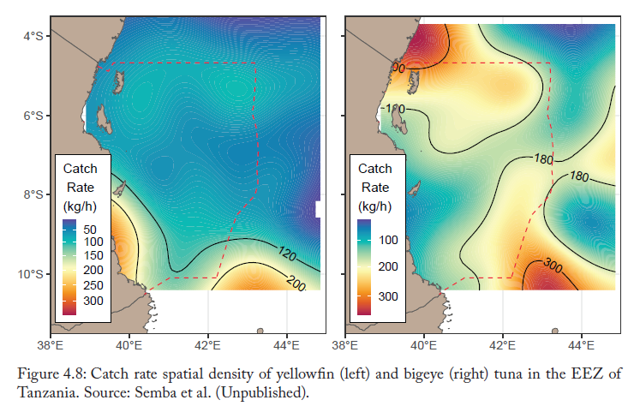

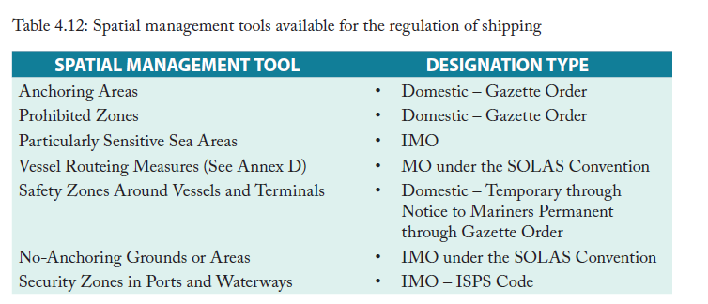

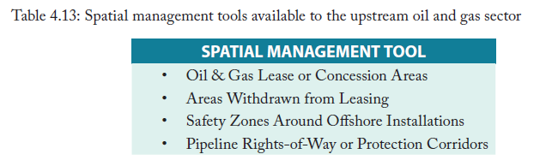

SECTORAL POLICIES - foreign example from URT Doc

| **SECTOR** | **POLICIES** |
| --- | --- |
| **CONSERVATION** | • The mangrove coverage will increase due to reforestation, prohibition of new shrimp aquaculture developments in this ecosystem and improved surveillance.  • The protected areas of "Mar Tropical de Grau" and "Manglares Delta del Rio Tumbes - Bahía Puerto Pizarro" will be established.  • Oil and gas activities will not be allowed within the protected areas. |
| **FISHERIES** | • Industrial shrimp fisheries will only be allowed within their original established zone.  • Fish stocks will recover due to compliance to regulations and new protected areas acting as fish reproduction areas.  • Joint management of shared species and quotas are established within the limits of maximum sustainable yield (MSY).  • Conflicts related to industrial fleet operating inside artisanal zones and foreign boats operating illegally will be overcome due to stronger surveillance.  • Development and improvement of the most efficient and environmental-friendly fishing technologies will be encouraged. |
| **AQUACULTURE** | • Prohibition of new shrimp aquaculture development in mangrove areas.  • Multi-trophic offshore aquaculture will be allowed in protected areas when it does not jeopardise their ecological objectives.  • Different types of offshore aquaculture will be established.  • Offshore aquaculture will not be allowed close to shipping routes and inside port development.  • There will be multi-uses related to offshore aquaculture (such as tourism).  • Management protocols will be improved, which will reduce environmental impacts. |
| **TOURISM** | • Improved environmental practices, quality standards and investments in infrastructure will add value to the sector in general, including nature-based and cultural tourism, attracting more national and foreign visitors. |
| **OIL AND GAS** | • New projects of exploration and exploitation of oil and gas will not be allowed in protected areas and reserved areas for artisanal fisheries in order to reduce conflicts with conservation, artisanal fisheries and tourism.  • Some decommissioned platforms will be used by other sectors (such as tourism or aquaculture).  • The decision will be taken on a case-by-case basis according to different aspects: environmental (evaluation of positive and negative impacts of removing or maintaining the infrastructure), technical (physical condition of the infrastructures), economic (viability of use by another sector), and legal (regulations and competences in relation to the infrastructure). |
| **MARITIME TRANSPORT & PORTS** | • Shipping will continue increasing due to growing demand for commodities (exportation) and goods (importation); however, boats will have reduced speed limit to avoid collision with cetaceans, while shipping lines will be rerouted to not pass through protected areas.  • Prohibition of the dredging deposit site inside the 1 NM Reserve Area for Species Reproduction in Ecuador.  • Prohibition of discharge of dredging material without treatment.  • Green port strategies will be in place.  • A new port will be developed in Zorritos in order to improve cabotage in Peru. |

